

Name ______________________________________________________________

 | LEARNING OUTCOMES
 | CCEA GCSE BIOLOGY: 1.2.1 - 1.2.7
 | UNIT 1.2 Photosynthesis
 | LEARNING OUTCOMES | PUPIL SELF-EVALUATION
 | Pupils should be able to: | Good | Average | Requires Attention
1.2.1 | Describe and explain the steps involved in testing a leaf for starch
 | Explain how and why a plant is destarched
 | Describe and explain the results of experiments used to investigate the need of light, carbon dioxide and chlorophyll for photosynthesis, including:
 | the use of sodium hydroxide (soda lime) to absorb carbon dioxide;
 | The use of a variegated leaf to illustrate the role of chlorophyll in the chloroplast in trapping light
 | Explain how to collect and identify oxygen collected from photosynthesising pondweed
1.2.2 | state the word equation for photosynthesis and recall
 | the balanced chemical equation to illustrate biology as
 | an evidence-based discipline
1.2.3 | Label the structure and shape of the mesophytic leaf
 | and identify its adaptations for gas exchange and light absorption,
 | to include epidermis, cuticle, palisade mesophyll with chloroplasts, spongy mesophyll, intercellular spaces, guard cells and stomata
1.2.4 | Explain how a plant uses the products of photosynthesis for respiration, storage and growth
1.2.5 | Describe experiments to investigate the factors affecting the rate of photosynthesis (light intensity, temperature and concentration of carbon dioxide)
 | and interpret data on the rate of photosynthesis in terms of limiting factors
1.2.6 | Describe how the use of artificial lighting, carbon dioxide and fertilisers can increase commercial crop production, including the economic implications
1.2.7 | Use hydrogencarbonate indicator to explain the relationship between photosynthesis and respiration in plants, to include:
 | the colour changes of hydrogencarbonate indicator
 | (high CO₂: yellow, normal CO_{2:} red, low CO₂ purple)
 | the compensation point

Terminology
destarch, chlorophyll, sodium hydroxide, soda lime, ethanol, corrosive, epidermis, cuticle, palisade mesophyll, spongy mesophyll, intercellular space, guard cells, stomata, heat shield, sodium hydrogencarbonate, limiting factor, economic implications, environmental factors, hydrogencarbonate indicator, compensation point
UNIT TEST RESULT: % GRADE:
COMMENT

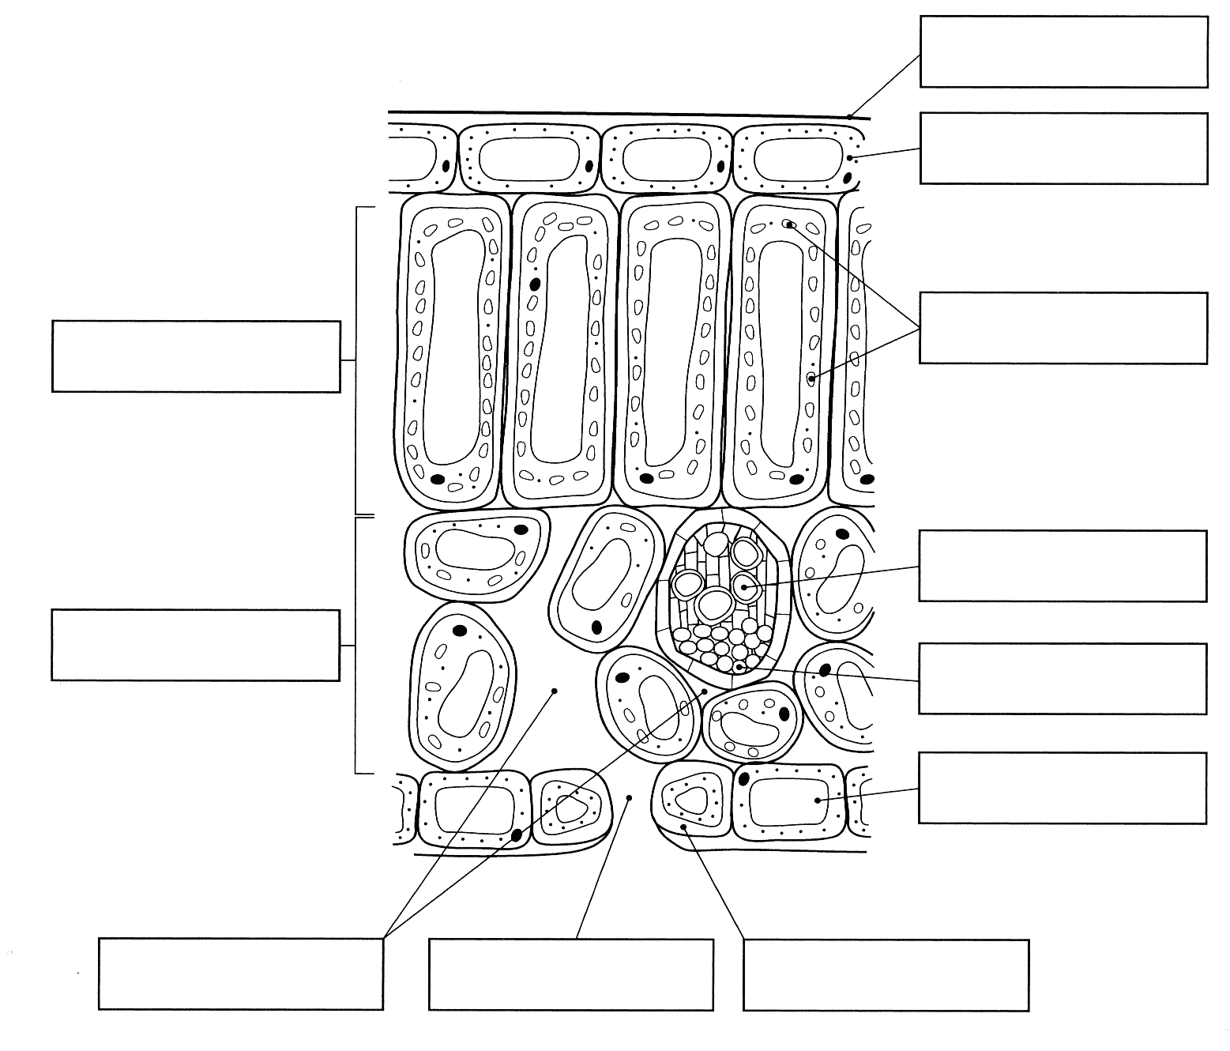

Cells and tissues found in a leaf
Epidermis Single layer of cells around the leaf: Upper and lower epidermis. Flat, no chloroplasts to allow light to pass through.

Cuticle Waxy layer covering the upper epidermis which reduces water loss.
Palisade mesophyll Layer of rectangular shaped cells found below the upper epidermis. Cells arranged side by side, no spaces – traps as much sunlight as possible. Many chloroplasts – lots of photosynthesis

Spongy mesophyll Layer of round cells below palisade cells with fewer chloroplasts, less photosynthesis. Contains air spaces called intercellular spaces.

Intercellular space Spaces between the spongy mesophyll cells which allow diffusion of oxygen, carbon dioxide and water between inside the leaf and the air outside
.
Stoma a small pore found between the cells of the lower epidermis.
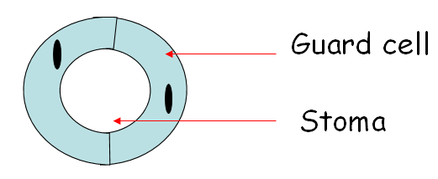

Guard cells are the 2 cells that surround each stoma which allow the stoma to open and close, controlling movement of gases in and out of the leaf.

Mid rib & veins Contain vascular bundles made up of xylem and phloem.
Xylem carries water to the leaf cells from the roots
Phloem carries sucrose sugar made in the leaf cells to other parts of the plant

To allow photosynthesis to take place efficiently leaves are adapted for maximum light absorption and gas exchange.
Complete the table below explaining how the leaf is adapted to achieve this.

LIGHT ABSORPTION

Adaptation | Explanation

GAS EXCHANGE

Adaptation | Explanation

- Paint 1cm x 1cm clear nail polish on the lower surface of a leaf and allow it to dry fully.
- Peel off the nail polish and set it in the centre of a glass slide, with the side that was touching the leaf uppermost.
- Sellotape the nail polish onto the slide.
- View the slide under the microscope on low power, X40, and locate an area containing stomata.
- Without moving the slide, increase the magnification to high power, X100.
- Record the number of stomata that you can see at X100.
- Repeat by painting nail polish on the upper surface of the leaf and record the number of stomata at the same magnification.

Leaf surface | Number of stomata  at X100 magnification
Lower surface
Upper surface

Which surface had the most stomata? ______________________________________
Can you suggest why? _______________________________________________
_____________________________________________________________________
How could the results of this investigation be made more reliable? ________________
_____________________________________________________________________
Draw diagrams of open and closed stomata in the space below.

Plants make their own food by the process of photosynthesis.
They take in the raw materials carbon dioxide and water and convert them into glucose and oxygen using energy from sunlight.
Photosynthesis occurs in the chloroplasts in plant cells. Chloroplasts contain the green pigment chlorophyll, which the plant uses to trap sunlight.

The word equation for photosynthesis.

Carbon dioxide + water → glucose + oxygen

The chemical equation for photosynthesis is written in the box below.

6CO₂ + 6H₂O C₆H₁₂O₆ + 6O₂

The oxygen made in photosynthesis is a waste product. It is either used in respiration or leaves the leaves through the stomata.
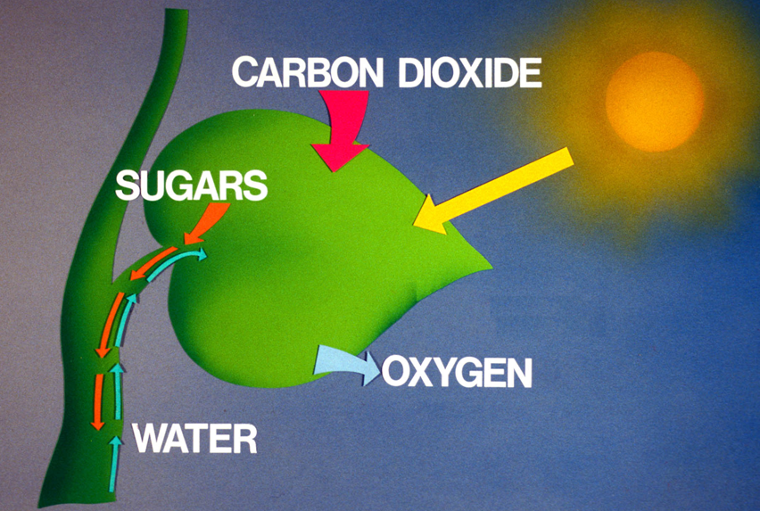

Sources of the raw materials for photosynthesis

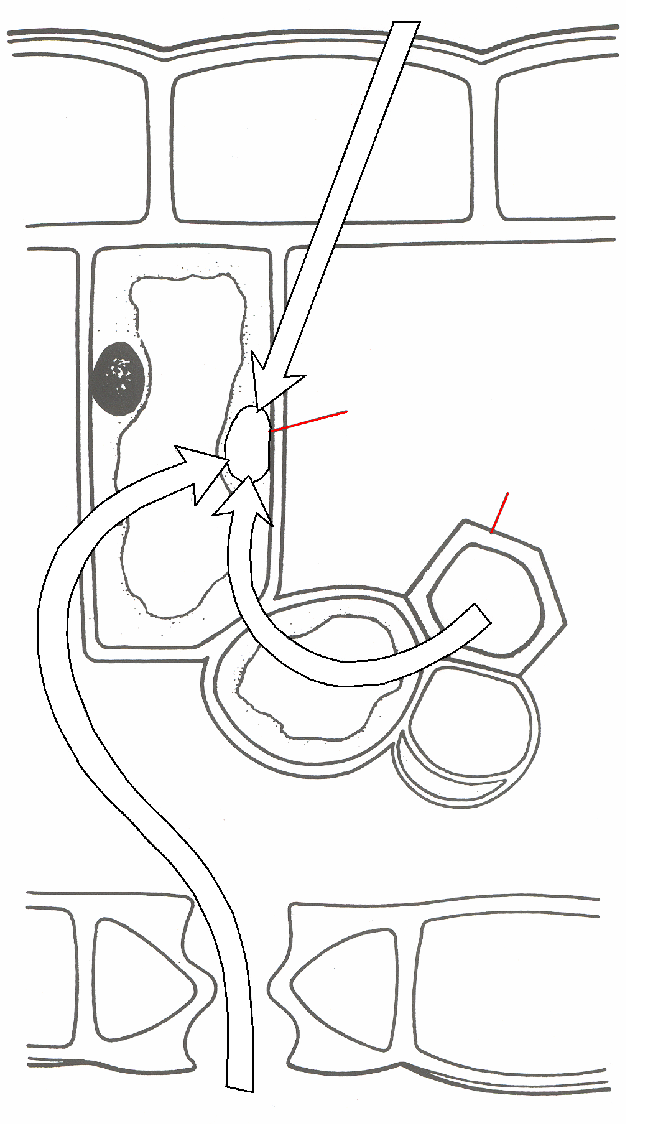



Where do plants get water for photosynthesis?
______________________________________________________________________
Where does the plant get the energy needed for photosynthesis to occur?
______________________________________________________________________
Most photosynthesis occurs in the palisade cells in leaves. How does the carbon dioxide needed for photosynthesis get from the atmosphere to the palisade cells inside a leaf?
______________________________________________________________________
______________________________________________________________________
______________________________________________________________________
Most stomata are found on the underside of leaves, explain why.
______________________________________________________________________
______________________________________________________________________
Glucose is the main product of photosynthesis, it used in respiration. This releases energy that cells need for growth and repair. Any glucose that is not used in respiration can be used to make starch, cellulose, amino acids and lipids.

Read the information on page 22 about starch, cellulose, amino acids and fats and then match the statements below with the correct substance.

STARCH
A very tough carbohydrate

Important source of energy storage in seeds and fruit such as sunflowers and olives.

Used to make proteins for growth and repair
CELLULOSE
Made by adding nitrogen from nitrates (taken up in the roots)

Stored in plant cells such as roots (potatoes, turnips) until it is needed.
AMINO ACIDS
Provides strength

Used to make cell walls

FATS
Converted back to glucose when needed for respiration.

Leaves make sugars during photosynthesis which can be stored as starch. If a plant contains starch this means that it must have been photosynthesising. Iodine solution is used as an indicator for starch. The following procedure is used to test if a leaf contains starch.
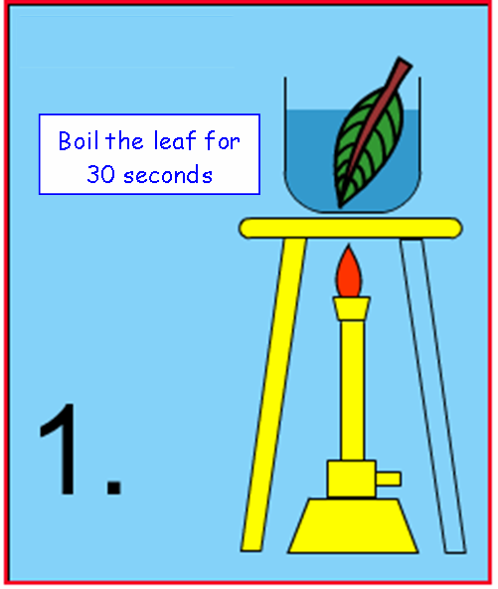
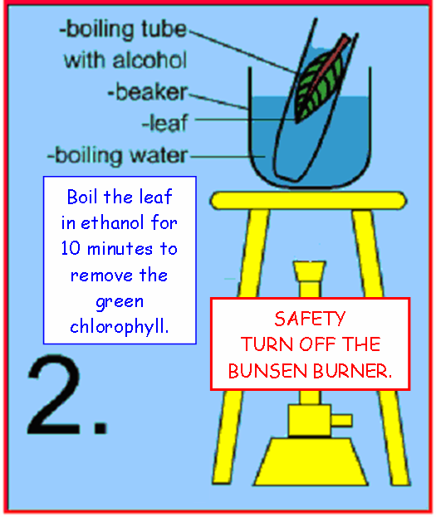

Kills leaf & ensures no further reactions occur

ALCOHOL IS FLAMMABLE

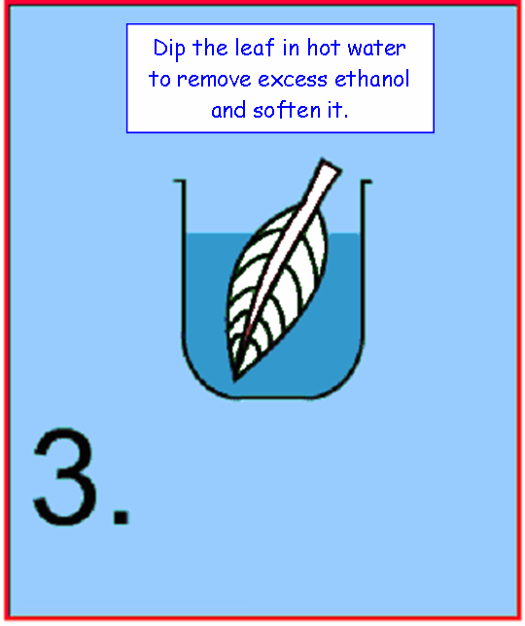
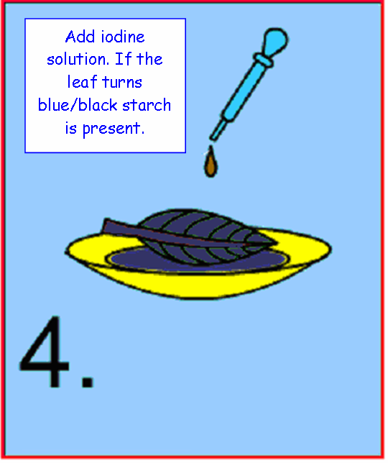

YELLOW/ORANGE MEANS
NO STARCH IS PRESENT

RESULTS OF TESTING A LEAF FOR STARCH
Colour each leaf to indicate what you will observe at each stage.

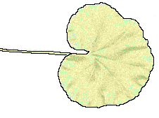

Leaf before testing

Leaf after boiling in ethanol

Leaf contains starch
Leaf DOES NOT contains starch

Plants used for photosynthesis experiments must be destarched. This is carried out by placing the plant in a dark place for 48hrs.

Why is it necessary to destarch a plant?
- All of the starch is removed from the leaf before the experiment begins.
- If the leaf tests positive for starch at the end of the experiment this shows that it must have been produced during the period of the investigation.

Is light needed for photosynthesis?

- Partially cover a leaf with black paper or tinfoil.
- Leave in light for 48hrs
- Test for starch

Leaf with tinfoil stencil
Leaf after testing for starch

Is CO2 needed for photosynthesis?

- Place a leaf in a conical flask containing soda lime (sodium hydroxide) (as below).
- The soda lime removes carbon dioxide.
- Repeat with a second leaf but replace the soda lime with water. This is the control.
- Leave in light for 48hrs
- Test for starch

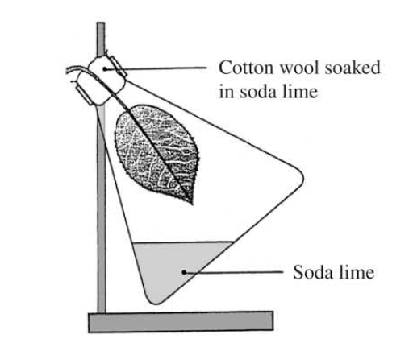
Control experiment

Colour of leaf after testing for starch
Colour of leaf after testing for starch

Is chlorophyll needed for photosynthesis?

- Use a variegated leaf (some parts have chlorophyll and others don’t)
- Leave in light for 48hrs
- Test for starch

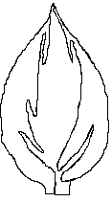
Leaf after testing for starch

no chlorophyll

chlorophyll

Variegated leaf

Measuring the rate of Photosynthesis

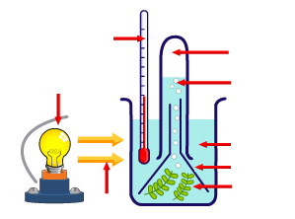

The rate of photosynthesis can be measured using the apparatus above in two ways:

- Counting the number of oxygen bubbles produced in a given time
- Measuring the volume of oxygen produced in a given time
This apparatus can be used to compare rates of photosynthesis in different conditions
e.g. by moving the position of the lamp you can measure the effect of light intensity on photosynthesis. The sodium hydrogen carbonate solution provides an excess of CO_{2.}
The thermometer is used to monitor the temperature.

Factors affecting the rate of photosynthesis & Limiting factors

The levels of CO₂, light and temperature all affect the rate at which photosynthesis happens. If photosynthesis happens at its maximum rate these factors must be at their optimum.
If one or more factors are in short supply then it limits the rate of photosynthesis
It is said to be a LIMITING FACTOR.

LIGHT INTENSITY
As a lamp moves closer to the beaker the light intensity increases and the rate of photosynthesis increases to a point.
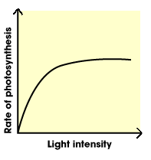
After this light has no further affect; either CO₂ or temperature becomes a limiting factor and the line levels out.

A heat sink is used to prevent the heat from the lamp affecting the results. This is a beaker of water that is placed between the lamp and the plant
The water heats up, but does not affect the amount of light reaching the plant.

Carbon dioxide concentration
As carbon dioxide concentration increases the rate of photosynthesis increases, to a point.
After this carbon dioxide concentration has no further affect; either light or temperature becomes a limiting factor.

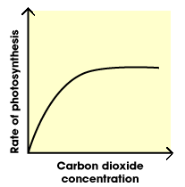

Temperature
As temperature increases the rate of photosynthesis increases, to a point, as there is more kinetic energy for the particles of carbon dioxide and water to move and react together.
At very high temperatures photosynthesis stops as enzymes are destroyed.

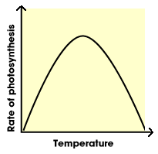

Crop production

Increasing light intensity, carbon dioxide concentration and temperature of a crop will result in more photosynthesis, more glucose being produced, more growth and bigger crop yields (a larger crop or bigger fruit/vegetables). If growers control the environmental conditions of their crops productivity and profits can be increased.
Sensors are used to monitor and control the conditions inside a greenhouse.
They detect changes in the conditions that are needed for photosynthesis.
By turning on and off specific apparatus it is possible to ensure there are no limiting factors so that photosynthesis and growth are at an optimum.
This also reduces running costs.

However the grower must consider the cost of increasing these conditions. It is important that the cost of the raw materials is less than increased sales to maximise profit.
A greenhouse grower can increase the following to increase yield.

LIGHT: Artificial lights are used to increase light intensity, day length AND season length

CARBON DIOXIDE can be increased for photosynthesis and growth by
- Burning fossil fuels e.g. paraffin
- Piping it in from canisters

TEMPERATURE can be increased to speed up the reaction in photosynthesis by
- Using electric heaters
- Burning fossil fuels

FERTLISER can be added to encourage growth.

BALANCING GASES

All living organisms respire during the day AND night.
the equation for respiration is:

In plants the glucose and oxygen produced in photosynthesis can be used for respiration
The carbon dioxide and water produced in respiration can be used photosynthesis.

Sometimes the two processes balance each other out.
BOTH photosynthesis and respiration happen during the day
Only respiration happens at night

Hydrogen carbonate indicator can be used to show this relationship

EXPERIMENT

Tube 1
Tube 2
Tube 3
Tube 4

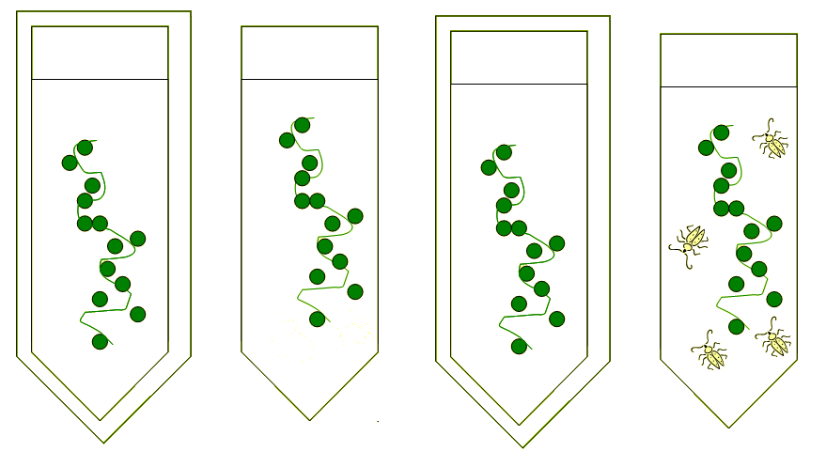

KEY: normal CO₂ = red; low CO₂ = purple; high CO₂ = yellow

Tube 1
The tinfoil stops light getting to the plant. This is like night when there is no photosynthesis but respiration still continues so carbon dioxide is released from the plant, turning the hydrogen carbonate indicator YELLOW.

Tube 2
There is a lot of light available to the plant. During the day the rate of photosynthesis is greater than the rate of respiration so more carbon dioxide is taken up by the plant than is released in respiration. The low carbon dioxide level makes the hydrogen carbonate indicator PURPLE.

Tube 3
The muslin reduces the light, this mimics dawn and dusk when the rate of photosynthesis is equal to the rate of respiration. All the CO₂ released in respiration is used in photosynthesis (we say there is no net output of gas). The bicarbonate indicator remains RED.
THIS IS CALLED THE COMPENSATION POINT

Tube 4
The water beetles are respiring as well as the pondweed and therefore more CO₂ is produced than can be used in photosynthesis causing the hydrogen carbonate indicator to turn YELLOW.












