
Glenlola Collegiate School
excellence through commitment, contribution and caring

NAME ________________________________________________________

 | LEARNING OUTCOMES
 | CCEA GCSE BIOLOGY: 1.4.1 - 1.4.5
 | UNIT 1.4: Enzymes and Digestion
 | LEARNING OUTCOMES | PUPIL SELF-EVALUATION
 | Pupils should be able to: | Good |  | Average |  | Requires Attention
1.4.1 | Know that enzymes are biological catalysts that speed up the rate of chemical reactions and are made of proteins, such as
 | • carbohydrase breaks down carbohydrates into sugars
 | • amylase breaks down starch to maltose
 | • lipase breaks down fats to fatty acids and glycerol
 | • protease breaks down protein to amino acids
 | Use the terms active site, substrate and product to explain the lock and key theory of enzyme action
 | Understand that enzymes are specific in the reactions they catalyse.
1.4.2 | Interpret the effects of temperature, pH and enzyme concentration on the action of enzymes in terms of:
 | ● low temperature causing reduced rates of collision between substrate and enzyme;
 | ● describing the maximum rate of reaction as the optimum;
 | ● denaturation occurring increasingly at levels above the optimum, explained as irreversible change to the shape of the active site that inhibits enzyme action;
1.4.3 | Know that enzymes are needed to break down (digest) large, insoluble molecules into small, soluble ones:
 | Know that enzymes are used commercially in biological washing powders
 | Know that enzymes are used in the digestion of food in the body, which can then be absorbed into the bloodstream
1.4.4 | Label a diagram of the component parts of the digestive system and identify their function. To include :
 | buccal cavity - the mechanical digestion by teeth and the chemical digestion of starch by amylase;
 | stomach - the production of gastric juice containing protease enzyme and acid, and the digestion of proteins;
 | liver - the production of bile, its storage in the gall bladder and its actions in the duodenum in neutralisation of acids and emulsification of fats
 | duodenum - enzyme production by the pancreas and the duodenal wall to include carbohydrases, lipases and proteases;
 | ileum - relate its structure to its function of absorption of digested food molecules and the ways it is adapted: large surface area (length, folds and villi), good blood supply, and thin and permeable membranes;
 | colon - large surface area for water absorption;
 | rectum & anus - storage and removal of faeces.

1.4.5 | explain how the structure of a villus (finger-like shape, single layer of surface cells, capillary network and lacteal) is adapted for the efficient absorption of digested food molecules.
Terminology
carbohydrase, amylase, lipase, protease, lock and key model, substrate specificity, kinetic energy, colllisions, substrate, product, active site, optimum, denature, inhibt, digestion, absorption, peristalsis, buccal cavity, mechanical digestion, chemical digestion, gastric juice, liver, bile, gall bladder, neutralisation, emulsification, pancreas, villus/villi, adaptation, permeable, lacteal, faeces
UNIT TEST RESULT: % GRADE:
COMMENT

An enzyme is ___________________________________________________________
_______________________________________________________________________
It is made of _____________________________________
Enzymes _______________ the energy needed for chemical reactions to take place.
The enzyme is unchanged at the end of the reaction so can be ____________________.
The substance an enzyme breaks down is called its _____________________________
and it produces a __________________________________

The chemical reactions that occur in the body are called __________________________
There are TWO types of enzyme reactions:

Catabolic reactions

Anabolic reactions

Catalase in the Liver

Our cells are always making poisonous chemicals, but do not die. This is because the cells use enzymes to breakdown the poisonous chemicals into harmless substances. Catalase is an enzyme found concentrated in mammalian livers. It catalyses (breaks down) poisonous hydrogen peroxide into harmless water and oxygen. This is a ___________________________________ reaction. Write a word equation for the reaction in the space below.

- An enzyme has a ____________________________________________________
- There is an indent in the enzyme called the ________________________________
- The substrate ___________________________________________ into the active site.

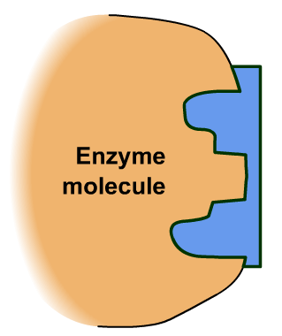
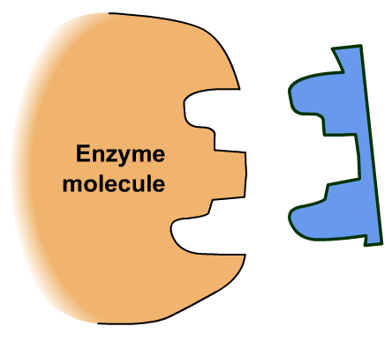
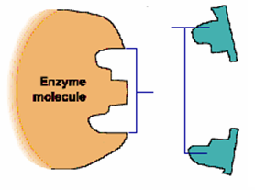

enzyme & substrate
enzyme & product
enzyme releases product

In this reaction the enzyme is ___________________ 2 substrate molecules to form a single product. This is a __________________________ reaction.

Draw a diagram in the space below to show what happened when the enzyme catalase breaks down hydrogen peroxide to make water and oxygen.

Enzyme specificity
- An enzyme only breaks down one _________________ type of substrate molecule
e.g. protease enzymes break down protein but not starch
- The _____________ of the active site will only fit one type of substrate molecule.
- Other molecules _________________________ so will not be broken down or joined together
- This is called the _______________________________________ of enzyme action.
- The ________________ acts as the _______________to unlock or lock the _________________________ molecules

SUBSTRATE
B

SUBSTRATE
A


ENZYME A

Explain why enzyme A can break down substrate A but not substrate B.
___________________________________________________________________________________________________________________________________________________________________________________________________________________________________________________________________________________________

The Effect of Temperature on
The Reaction between Starch and Carbohydrase

The enzyme carbohydrase breaks down starch into sugar.

- Add a drop of iodine solution to each well in a spotting tile.
- Label THREE boiling tubes, A, B, C, and place them in a boiling tube rack.
- Add 5 cm³ carbohydrase from the fridge (5ºC) to test tube A.
- Add 5 cm³ carbohydrase at room temperature (20ºC) to test tube B.
- Add 5 cm³ carbohydrase which was boiled (100ºC) to test tube C.
- Add 1 cm³ starch solution to boiling tube A with a syringe and start a stop clock.
- Immediately remove a drop of the starch and carbohydrase mixture and add it to the
iodine solution in one of the wells in the spotting tile.
- Record the colour.
- Repeat each minute until there is no colour change.
- Repeat for the other temperatures.

 | COLOUR OF IODINE SOLUTION at 1 min time intervals
Temperature /ºC | 0 | 1 | 2 | 3 | 4 | 5 | 6 | 7 | 8 | 9 | 10
5
20
100

Interpretation of Results

In which boiling tube did the starch disappear fastest?
_________________________________________________________________________
In which boiling tube/s did the starch not get broken down?
_________________________________________________________________________
Does cooling the enzyme affect its activity? _________________________________________________________________________
Does boiling the enzyme affect its activity? _________________________________________________________________________
_________________________________________________________________________
_________________________________________________________________________

The Effect of Temperature on Enzyme Activity

- Low temperatures reduce the rates of collision between substrate and enzyme because there is ___________________________________________, so there are fewer reactions and the ____________________________________________________________________
- As temperatures are increased there is _____________________________________ available, there are more substrate enzyme collisions and the _________________________
___________________________________________________________________________
- The temperature at which an enzyme works at its maximum rate of reaction is called the __________________________________________________________________________
- At temperatures above the optimum the enzyme ______________________________, the rate of reaction __________________ and eventually the reaction stops. This is due to an _____________________ change to the ______________________________________ thereby __________________________ enzyme action.
- The enzyme is said to have been ________________________________________
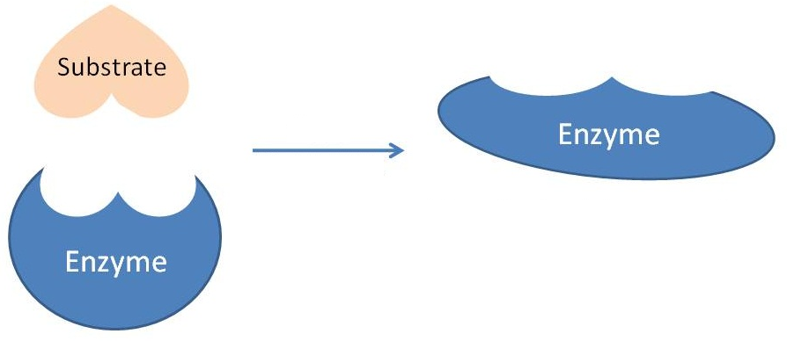

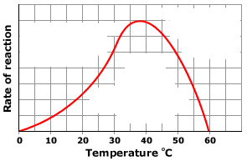

The Effect of pH on
The Reaction between Starch and Carbohydrase

The enzyme carbohydrase breaks down starch into sugar.

- Add a drop of iodine solution to each well in a spotting tile.
- Label THREE boiling tubes, A, B, C and place them in a boiling tube rack.
- Add 1 cm³ hydrochloric acid to test tube A.
- Add 1 cm³ distilled water to test tube B.
- Add 1 cm³ sodium hydroxide to test tube C.
- Add 5 cm³ carbohydrase to test tubes A, B and C.
- Add 1 cm³ starch solution to each boiling tube with a syringe AT THE SAME TIME
and start a stop clock.
- Immediately use a dropper to remove a drop of each solution and place it in one of the
wells on a spotting tile. USE A CLEAN DROPPER FOR EACH BOILING TUBE.
- Record the colour of the iodine solution in the table below.
- Repeat after 5, 10 and 15 minutes.

 | COLOUR OF IODINE SOLUTION
 | A | B | C
TIME / min | ACID  pH 3 | DISTILLED WATER  pH 7 | ALKALINE  pH 10
0
5
10
15

Interpretation of Results

In which boiling tube did the starch disappear fastest?
_________________________________________________________________________
In which boiling tube/s did the starch not get broken down?
_________________________________________________________________________
Does changing the pH of the enzyme affect its activity? _________________________________________________________________________

The Effect of pH on Enzyme Activity

- The pH at which an enzyme works at its maximum rate of reaction is called the __________________________________________________. This is usually pH 7.
- At pH values ____________________________________________________________ the rate of reaction ___________ and eventually the reaction stops.
- This is due to a ________________________ change to the shape of the active site thereby inhibiting enzyme action.
- The enzyme is said to have been ________________________________________

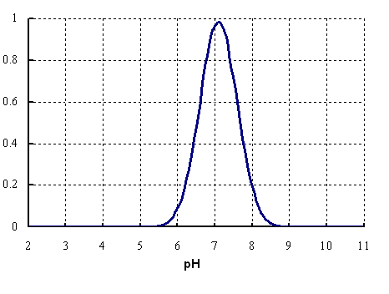

Rate of reaction

ACTIVITY

Add a line to the graph to show the rate of reaction for an enzyme with an optimum pH of 4.

The Effect of enzyme concentration on
The Reaction between Starch and Amylase

The enzyme amylase is a carbohydrase found in saliva which breaks down starch into sugar.

The following procedure may be used to investigate the activity of amylase at different concentrations.

- Add a drop of iodine solution to each well in a spotting tile.
- Label THREE boiling tubes, A, B, C and place them in a boiling tube rack.
- Add 5 cm³ 0.1M amylase to test tubes A.
- Add 5 cm³ 0.2M amylase to test tube B.
- Add 5 cm³ 0.4M amylase to test tube C.
- Add 1 cm³ starch solution to each boiling tube with a syringe AT THE SAME TIME
and start a stop clock.
- Immediately use a dropper to remove a drop of each solution and place it in one of the
wells on a spotting tile. USE A CLEAN DROPPER FOR EACH BOILING TUBE.
- Record the colour of the iodine solution in an appropriate table.
- Repeat after 5, 10 and 15 minutes.

Interpretation of Results

In which boiling tube might you expect the starch to disappear fastest?
_________________________________________________________________________
In which boiling tube/s might the starch not get broken down?
_________________________________________________________________________
How do you think that changing the concentration of the enzyme would affect its activity? _________________________________________________________________________

_________________________________________________________________________

The Effect of Enzyme Concentration on Enzyme Activity

- The more enzymes there are the ____________________________________________
- This is because there are ___________________________________________________ for substrates to attach to.
- However eventually _________________________________________ because there are _________________________________________________________________________ ACTIVITY
The protein in egg white is called albumen. The cloudy albumen is broken down by the enzyme protease to form a clear solution of amino acids. The enzyme was made up in four different concentrations. The time taken for each enzyme concentration to break down the albumen was measured and the rate of reaction was calculated as the mass of albumen broken down per minute.

Enzyme concentration/ M | 0.0 | 0.1 | 0.2 | 0.3 | 0.4 | 0.5
Rate of Reaction  /g min⁻¹ | 0 | 0.5 | 1.0 | 1.5 | 2.0 | 2.0

Use the information to draw a graph of the effect of protease concentration on the rate of albumen breakdown. HINT: IV on x axis, DV on y axis.

Biological detergents

A student posted a question on AskJeeves about how biological washing powders work. Read the response on the laminated handout and answer the questions that follow.

Why are enzymes added to biological washing powders?
______________________________________________________________________________________________________________________________________________

Name the common enzymes that are added and explain what they do. _______________________________________________________________________
_______________________________________________________________________
_______________________________________________________________________
_______________________________________________________________________
_______________________________________________________________________

Biological washing powders are most effective at low temperatures, 30 ºC or 40ºC.
What do you think happens when you use them in a hot wash at 90 ºC _______________________________________________________________________
_______________________________________________________________________
______________________________________________________________________________________________________________________________________________

Why is it better to use biological detergents containing enzymes rather than traditional soapy detergents? _______________________________________________________________________
_______________________________________________________________________
_______________________________________________________________________

What are the advantages of washing clothes at 30 ºC or 40 ºC? _______________________________________________________________________
_______________________________________________________________________
_______________________________________________________________________
_______________________________________________________________________

Are there any problems associated with using biological washing powders? _______________________________________________________________________
_______________________________________________________________________

Another name for the digestive system is the alimentary canal.
The process of digestion has 5 functions:
Ingestion:
Digestion:
Absorption:
Assimilation:
Egestion:

Food is broken down into smaller pieces by biting, chewing, churning, bile action.
These pieces are _______________________________________________ but have a ____________________________________________________ for enzymes to work on.

Enzymes break chemical bonds to make insoluble food particles soluble.
REMEMBER:
Carbohydrases break down
Proteases break down
Lipases break down

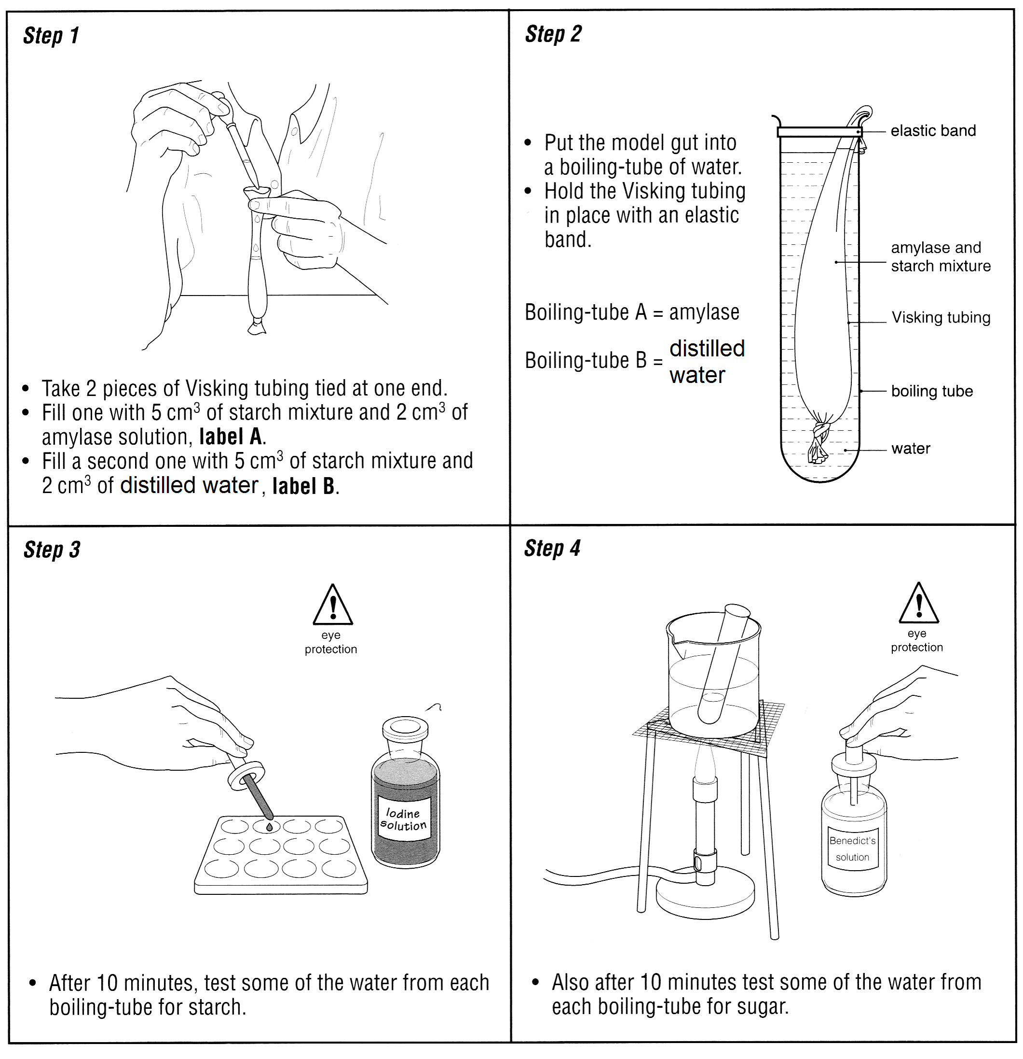

QUESTIONS
- Did you find any starch in the water inside the boiling tubes?
________________________________________________________________________
- Explain your answer to question 1.
________________________________________________________________________
________________________________________________________________________
- Did you find any sugar in the water inside the boiling tubes?
________________________________________________________________________
- Explain your answer to question 3.
________________________________________________________________________________________________________________________________________________
________________________________________________________________________________________________________________________________________________
________________________________________________________________________
________________________________________________________________________
- What was the purpose of using distilled water in boiling tube B?
________________________________________________________________________
- What do your results tell you about the size of the molecule that can pass through
Visking tubing?
________________________________________________________________________
- What part of the apparatus was like:
  - the food in your gut? _____________________________________________
  - your gut wall? _____________________________________________
  - the blood around your gut?_____________________________________________

The Human Digestive System

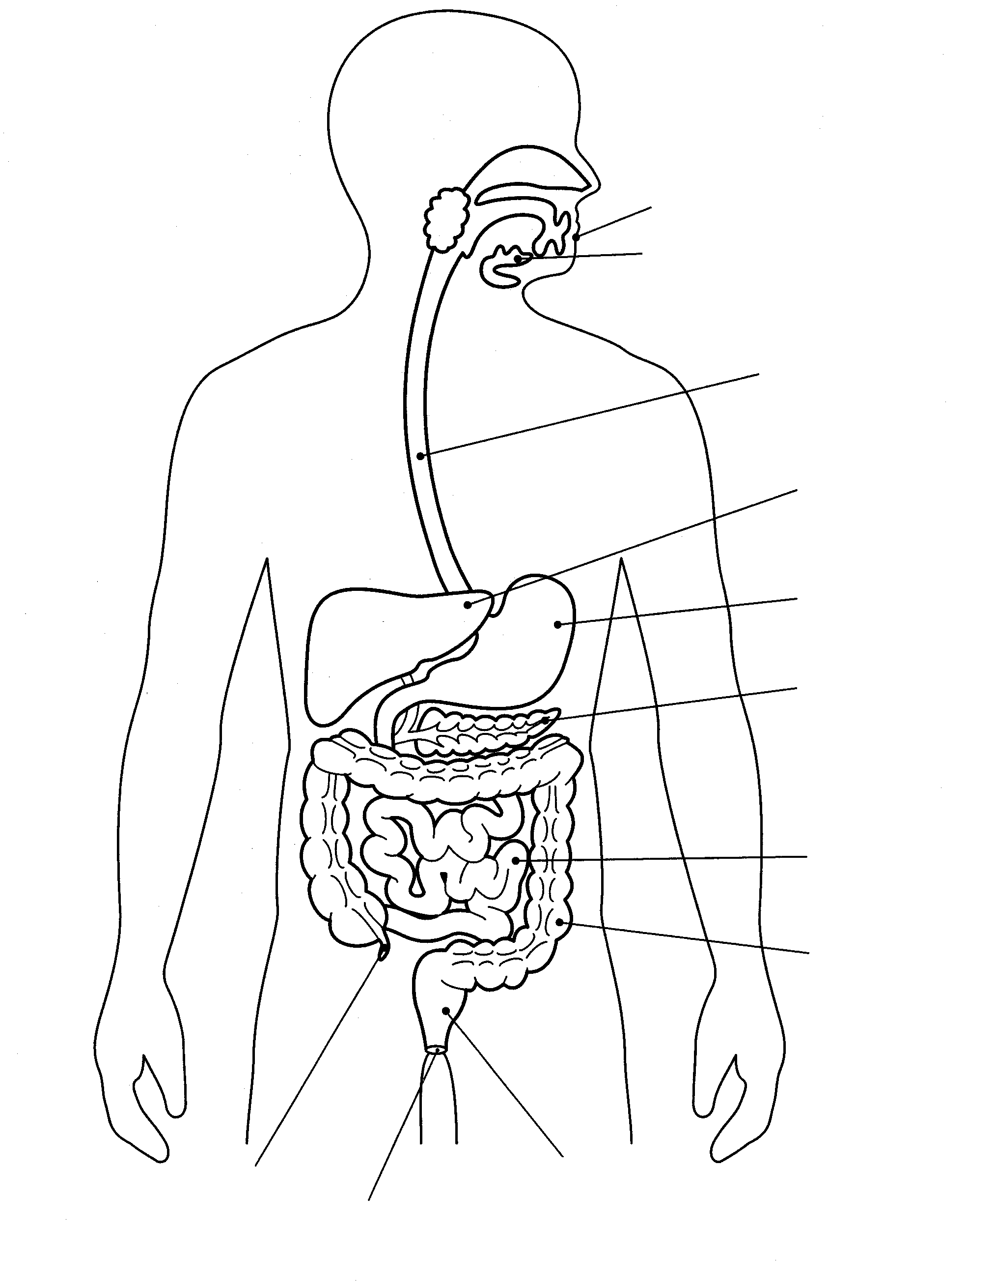

Chewing and grinding of food by the teeth physically breaks down the food in the mouth. Saliva produced in the __________________________________ contains the enzyme _____________________________________ which breaks down starch into sugar (maltose).

The ball of food ready to swallow is called the _______________________________

NO FOOD IS BROKEN DOWN HERE
Muscles in the wall of the oesophagus contract, pushing food down to the stomach.
This is called ____________________________________

FOOD

The strong muscle walls contract to churn and mix food with stomach juices, called ________________________________ Cells in the stomach wall produce a ___________________________________________ that digests __________________, breaking them down into __________________________________.

The stomach cells also produce _______________________________, HCl, which:

A circular, ___________________________________________________ at the exit of the stomach opens to allow food into the small intestine.
It _____________________________________________________________________

Bile, made in the __________________ and stored in the _________________________ passes along the __________________________________________ into the duodenum.
Bile breaks fats into very small droplets, _______________________________________ for enzymes to work on. This is called _________________________________________
Bile is ________________________ and therefore also neutralises __________ from the stomach.

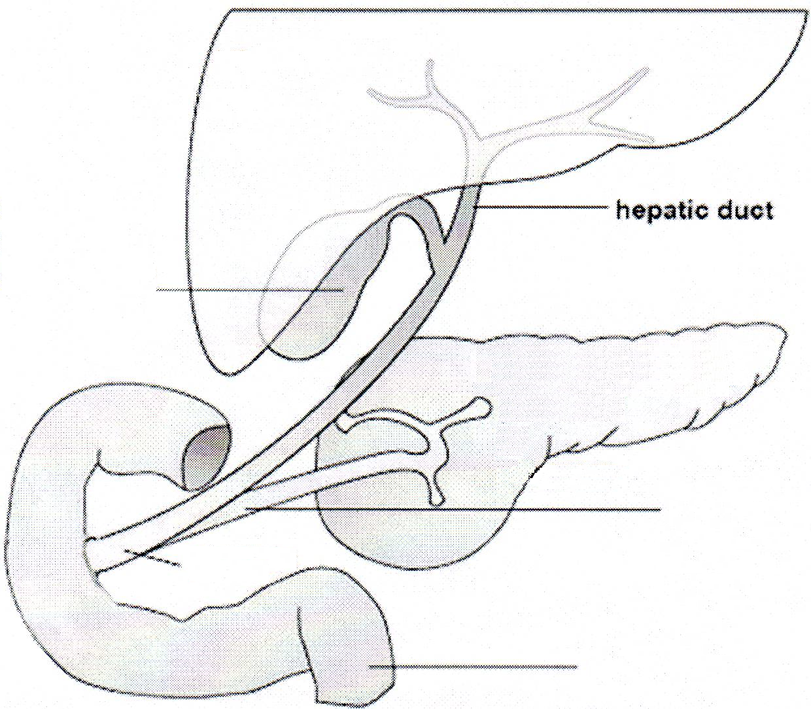

ENZYMES are added to the duodenum from:
- The ___________________________________________________________
- The ___________________________________________________________
Carbohydrases break down

Proteases break down

Lipase breaks down

The main function of the ileum is _________________________________________
The walls are adapted for efficient diffusion of the soluble products of digestion.

- Long length (5m), FOLDS & villi ___________________________________________
_____________________________________________________________________
- Villi contain blood vessels ________________________________________________
- Villi contain lacteals ____________________________________________________
- The walls are one cell thick ______________________________________________
_____________________________________________________________________

The absorbed nutrients, amino acids and sugars are carried in the blood to the liver in the ______________________________________________________________________

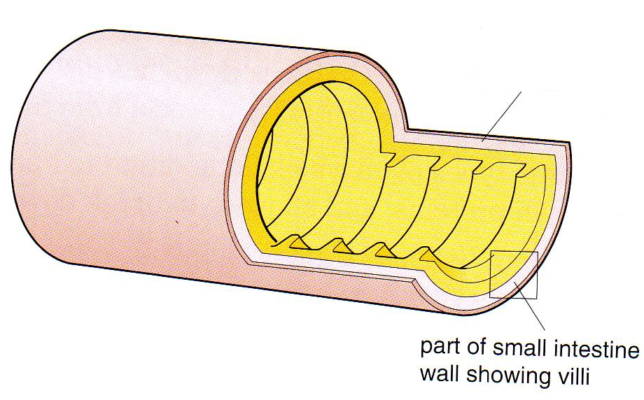
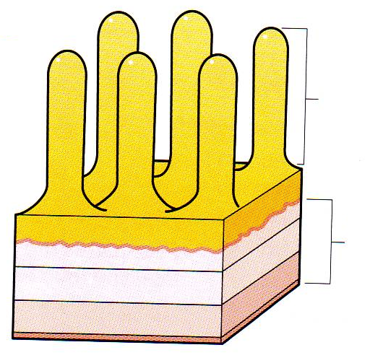
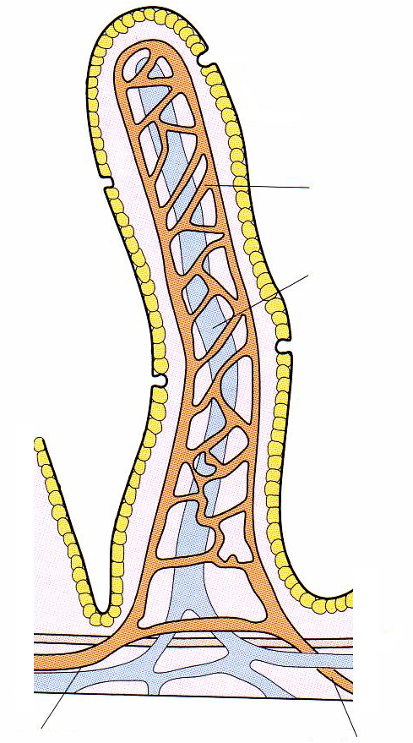

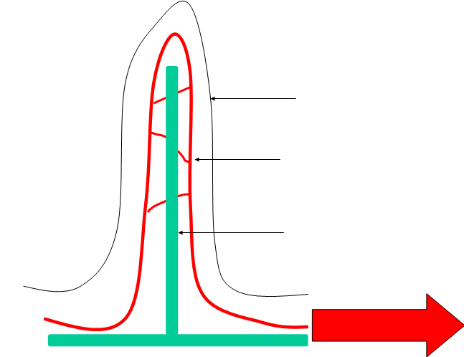

NO DIGESTION OCCURS HERE

The colon has ____________________________________________________________
________________________________________________________________________
from the fluid we drink, food we eat mucus and digestive juices. It also absorbs ________________________________________________________________________

Solid waste made up of undigested food, bacteria and cells from the gut forms ________________________, which is ________________________in the rectum before ___________________________________ of the body through the anus.

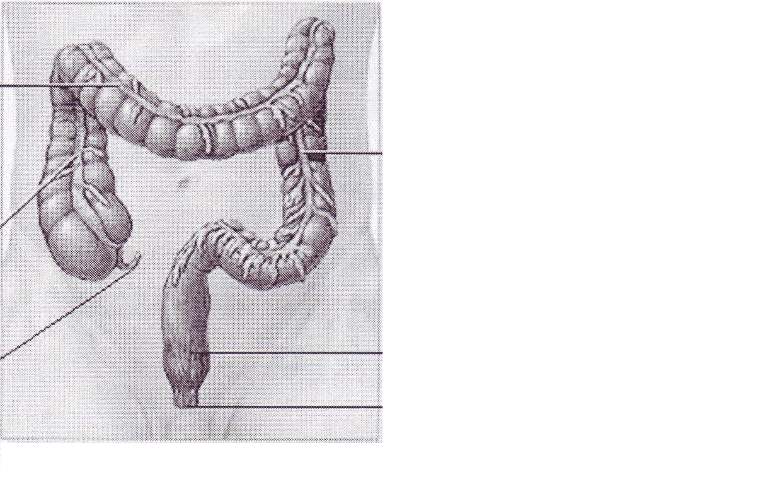
transverse
colon
ascending
colon
descending
colon
appendix



