TOPIC 3.3 | Physical Properties of Stars

3.3a demonstrate an understanding that stars in a constellation are not physically related but that stars in a cluster are associated gravitationally

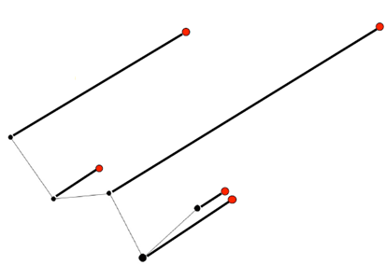
A ‘constellation’ is the name given to a pattern of stars in the sky e.g. Ursa major, Orion, Cygnus. They are not related to one another and are often huge distances apart. If viewed from a different part of the solar system a constellation will have a different appearance. It also changes over long periods of time.
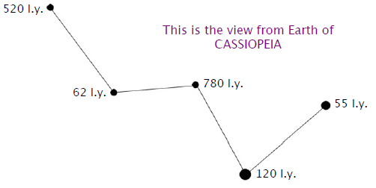

3 stars are much closer to Earth than the other 2, causing a totally different view if seen from one side.

Star clusters are a physical grouping of stars which are associated with each other gravitationally as the distances between the stars are relatively small. All the stars in a specific cluster are the same age and the same distance from Earth. Their appearance does not change over long periods of time.
Clusters of stars come in two basic types;
Open clusters contain hundreds of young stars found in the spiral arms of galaxies e.g. M36 and the Pleiades. They are irregular in shape.
Globular clusters contains tens of thousands of very old stars found in the central halo/bulge of a galaxy e.g. M3. They are spherical in shape.

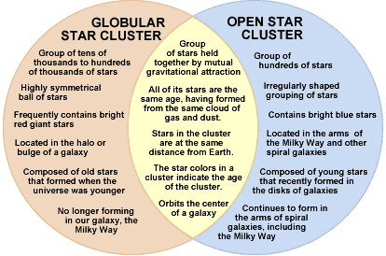

3.3b distinguish between optical double stars and binary stars
Binary stars consist of two stars which are very close and orbit around a gravitational point between them. This causes one of the stars to wobble, which can be seen with powerful telescopes. It is also possible to see a change in the light intensity as one star passes in front of or behind the other. Examples include

Optical double stars are not actually close together but appear so from our line of sight. Albireo, the bright star at the head of Cygnus consists of two stars of different colours, one is very orange the other bluish white. It can be seen with binoculars. Mizar and Alcor form an optical double in Ursa Major.

3.3c demonstrate an understanding of the apparent magnitude scale and how it relates to observed brightness of stars

Object | Magnitude
Sun | -27
Moon | -12
Venus | -4
Sirius (brightest star) | -1.2
Faintest stars visible to the naked eye | +6
Stars may look bright because they are close to us, very large or very hot.
The apparent magnitude (m) of a star is a measure of how bright it appears to be in the sky from Earth. The smaller the magnitude, the brighter the star, so a magnitude of -1 is brighter than 1.
A change in magnitude of 1 increases brightness by 2.5 times. A difference of 5 magnitudes between 2 stars means one appears to be 100 times brighter than the other.

Magnitude difference | Brightness ratio
1
2
3
4
5
6

HOMEWORK:
Find the magnitude of the stars: SPICA ____________; AVIOR __________; POLARIS __________.
EXAMPLE CALCULATIONS:

- The apparent magnitudes of 2 stars are 2.6 and 5.6. How many times is one brighter than the other?

- In a constellation, the magnitude of star β is – 0.3 and the magnitude of star ε is 1.7. How many times does β appear brighter than ε?

- In another constellation, star δ has an apparent magnitude of 3.3. Star α appears to be 6.25 times brighter than δ. What is its apparent magnitude?

3.3d use the scale of apparent magnitude
This is the calculations you have just completed.
3.3e describe the method of heliocentric parallax to determine distances to nearby stars

Heliocentric means that the Sun is at the centre of the Solar System and the planets revolve around it.
This means that stars which are relatively near to the Earth can seem to move against the background (much further away) stars when viewed 6 months apart.
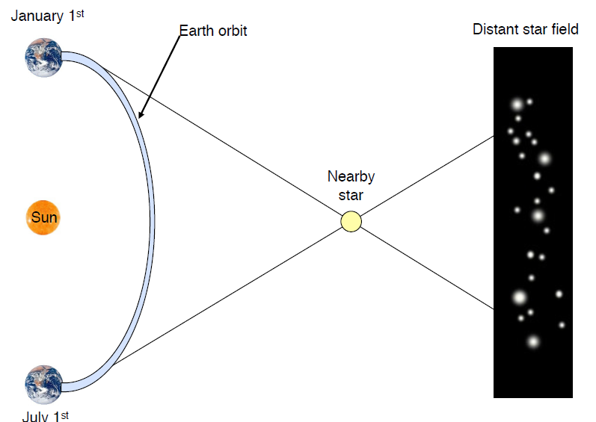

A telescope is used to measure how much the angle of view has changed over this time. This is called the angle of shift and stars closer to Earth have bigger angles.

Astronomers measure this angle in seconds of arc or arcsecs rather than degrees because the angle is so small.
(DON’T GET CONFUSED WITH TIME).

1° = 60 minutes of arc
1 minute of arc = 60 seconds of arc
1° = 3,600 arcsec
Knowing this angle and the distance from the Sun to Earth allows us to use trigonometry to calculate the distance of the star from the Sun.

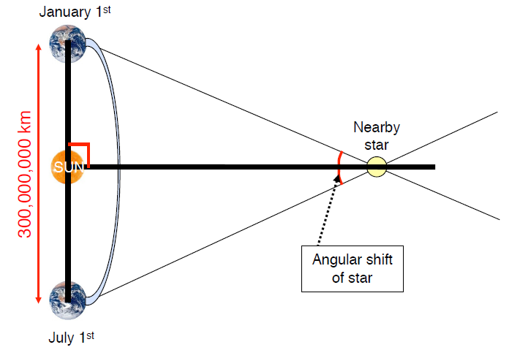

Drawing a line at 90º from the star to the Sun gives 2 right angled triangles. We know that:
The distance from The Sun to Earth is 1AU = 150 000 000km
The angle α is half of the angle of shift. This is called the angle of parallax.
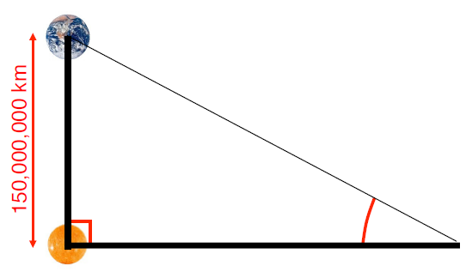

p

d

To find the distance from the Sun to the star (d) we use the equation:
d = 1 / p

3.3f recall the definition of one parsec (pc)
This would give a really large distance in km, so astronomers use a unit called a parsec to measure distances in space.
One parsec (1pc) is the distance at which a star has a parallax angle (p) of 1 arcsec
This is equivalent to 3.09 x 10¹⁶m; 2.06 x 10⁵ AU; or 3.26 light years.

3.3g recall the definition of absolute magnitude
The absolute magnitude(M) of a star is a measure of its true output of energy and is defined as the star’s apparent magnitude if it was observed from a distance of 10 pc.
We say that the apparent magnitude of the star tells us how bright the star appears to be but the absolute magnitude tells us about the true brightness of the star.

3.3h demonstrate an understanding of the inverse square law nature of the intensity of light

As an object moves further away from the Earth it will appear dimmer. In fact each time the distance is doubled the light intensity is reduced to one quarter. This can be written as an equation, known as the Inverse Square Law for Light Intensity:
light intensity = 1 / d² where distance is measured in parsecs
DISTANCE (d) | DISTANCE SQUARED (d²) | LIGHT INTENSITY
1 | 1 | 1
2 | 4 | ¼; 0.25
3
4
5
6

3.3i demonstrate an understanding of, and perform simple calculations involving, apparent magnitude (m), absolute magnitude (M) and distance (d in pc), using this formula: M = m + 5 – 5 log d
involving powers of 10 only (students are not required to calculate d using this equation, only M and m)

The absolute and apparent magnitudes of a star are related to the distance from us by the equation
M = m + 5 – 5 log d
where M is absolute magnitude, m is apparent magnitude and d is the distance in pc.
This is known as the Distance Modulus Formula.
You will be given this formula in an exam question and only required to calculate M or m and d would be given in multiples of 10. This makes using logs easier as log 10 = 1; log 100 = 2; log 1000 = 3 etc.

- A star of apparent magnitude 4.2 is 10pc from the Sun. Calculate the absolute magnitude of the star.
m = Equation: M = m + 5 -5logd
d = insert values:
M = Answer: m =
- A star of absolute magnitude -1.2 is 100 pc from the Sun. Calculate the apparent magnitude.
M = Equation: M = m + 5 -5logd
d = insert values:
m = Answer: m =
3.3j identify a Cepheid variable star from its light curve and deduce its period

The luminosity of a variable star changes over time. There are two types of variable stars, Cepheid variables and binary stars
A Cepheid variable is a star that pulses frequently and we can see the light they produce dip and rise over a short period of time, returning to the same luminosity a few days later. This is because they regularly expand and contract in size.

Graphs showing how the light intensity of a star changes over time are called light curves. The light curve for a Cepheid variable star is a non-symmetrical curve.

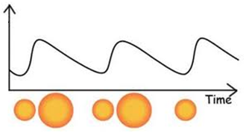
luminosity

The period of a Cepheid variable is the time between two corresponding points on the graph e.g. from peak to peak or trough to trough. It is usually about 7 days.

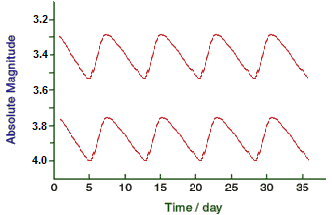
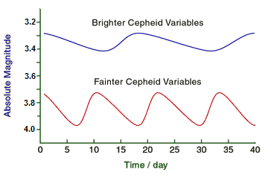

The longer the period between peaks of brightness the brighter the star is.
All Cepheids with the same brightness have the same period of variation and two Cepheids with the same period are equally bright. Therefore, if one appears dimmer it must be due to it being further away.
This means that Cepheid variables can be used to measure distance.
3.3k explain how Cepheid variables can be used to determine distance

In 1912 Henrietta Leavitt, an astronomer at Harvard College observatory, discovered an important connection between the period (the time between moments of maximum brightness) and its actual brightness/absolute magnitude. This is now known as the period-luminosity relationship.
If you measure the period of a Cepheid star you can use the period-luminosity relation to find out how bright the star really is, its absolute magnitude, M.
Knowing the absolute magnitude and then measuring the apparent magnitude, m, (how bright it appears to be) you can then work out the distance of the star from the Earth using the distance modulus equation.

M = m + 5 – 5logd

Astronomers call Cepheid variables standard candles. The discovery of Cepheid variables in the Andromeda nebula (M31) enabled its distance from Earth (over two million light years) to be found.

To find out how far away a star is:
1. Measure how long it takes to get brighter and dimmer (i.e. the period).
2. Once you know the period, use the period-luminosity graph to find its absolute magnitude, M.
3. Measure how bright it appears (its apparent magnitude, m).
4. Calculate how far away the star is by using the distance modulus equation (M=m+5-5 log d).
N.B. You need know this method in theory only – you would never need to carry out the calculation, but you do need to describe the sequence outlined above.
It only works for relatively nearby stars.
3.3l identify a binary star from the light curve and deduce its period
In a binary star system two stars rotate around each other. The light curve would be a straight line with two different sized dips.

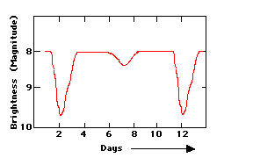

Like the Cepheid light curve, the period is deduced by measuring the peak to peak or trough to trough difference.
We can tell from this light curve that it takes 10 days for one of the stars in the binary to orbit completely around the other. Astronomers would say "the orbital period of the binary system is 10 days."

3.3m explain the causes of variability in the light curve of a binary star
Usually one star is brighter than the other. During the orbit one star will pass in front of the other.
The smaller dip would be when the dimmer star is blocking the brighter star and the largher dip would be from when the brighter star is blocking the light of the smaller star. This is known as an eclipsing binary star.

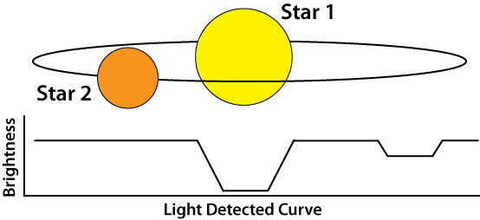

Draw diagrams to show the position of the two stars at the dips in brightness.

3.3n demonstrate an understanding of what information can be obtained from a spectrum, including chemical composition, temperature and radial velocity
The ‘electromagnetic spectrum’ is the range of all the types of electromagnetic radiation. Radiation is energy that travels in waves and spreads out as it goes. Different types of radiation have different wavelengths and so will have different frequencies i.e. different numbers of waves per second.
Values on the left of the diagram below have very long wavelengths, so their frequency is low and they have low energy, whilst those on the left have short wavelengths, high frequencies and high energy.
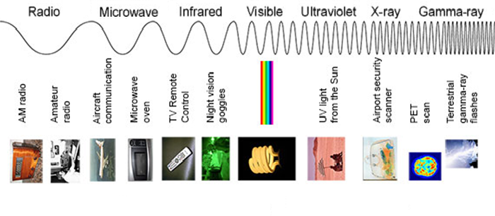

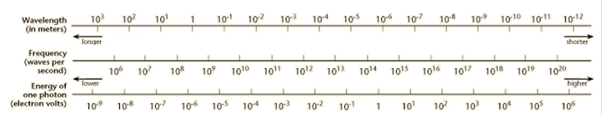

The light that we see is described as white light, but is made up of a continuous spectrum of colours. We can see these colours when light is split using a prism or by water droplets in the atmosphere, forming the colours of the rainbow. ROYGBIV.
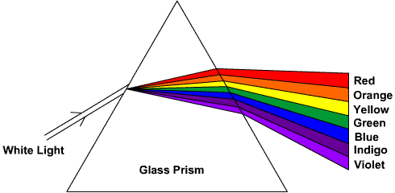

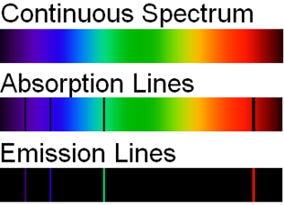
Energy from any hot opaque body, such as a hot, dense gas (or a solid) produces a continuous spectrum; a complete rainbow of colours.
When the radiation from a hot opaque object passes through a cool, transparent gas, the molecules in the gas will absorb some of the energy. Different elements absorb different wavelengths. Therefore, radiation leaving the gas will be missing specific wavelengths. This is seen as a spectrum with dark absorption lines.
The energy absorbed by the gas is re-emitted. If we view this energy against a dark background, bright coloured emission lines can be seen.
The light from a star filters through its atmosphere and the chemicals in the photosphere absorb some of the light energy. Therefore, only some forms of radiation will be seen leaving that star.
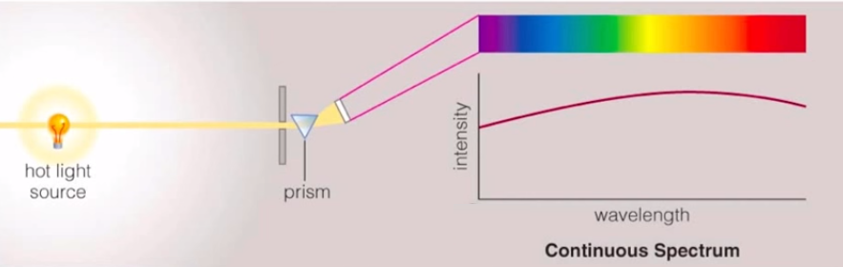

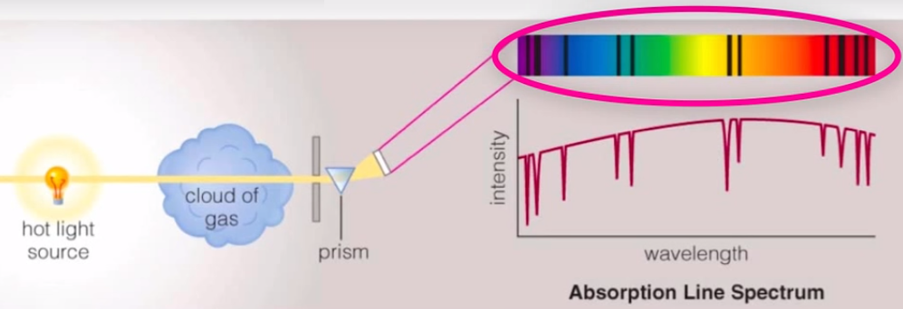

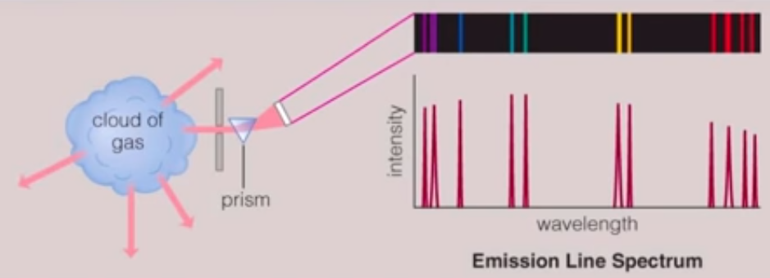

The absorption spectra that we see coming from stars means that the star's atmosphere contains certain types of molecules which absorb light of that colour. The lines are called Frauenhofer lines, and the solar spectrum is sometimes called the Frauenhofer spectrum. These lines are produced mainly in the photosphere of the star.
Astronomers can use the information from these "spectral lines" (absorption and emission lines) to figure out what a star is made of. So a star’s spectrum can give information about the chemical composition of the star.
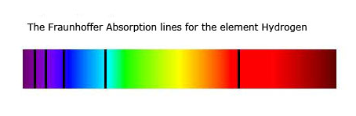
Spectral lines video

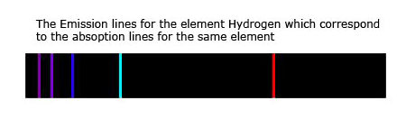

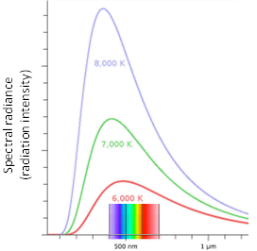

The temperature of a star can be obtained using
a graph of the intensity of a stars radiation, called a
Plancks Curve. The peak in intensity of a star’s radiation
is related to its temperature:
- a peak at shorter wavelengths (blue) tell us the star is hot
- whilst a peak at longer wavelengths (red) tells us it is cooler.

Radial Velocity
Radial velocity is how fast an object is travelling in the direction of the line of sight, towards or away from us.

Each element has its own unique absorption lines that can be measured in a laboratory. However, if we move the element towards or away from us the absorption lines in its spectrum appear to move.

This is because as objects move towards us the light waves are squashed together giving shorter blue wavelengths but as they move away the light waves spread out producing longer red wavelengths.

When an object such as a Solar System object, star or galaxy moves we can measure changes in its spectrum. These changes are known as Doppler shifts.
If the object is moving away from us, the absorption lines will have longer wavelengths; this is known as red shift.
If they are moving towards us, the absorption lines will have shorter wavelengths, and is known as blue shift.

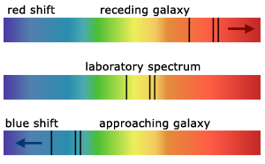
object moving away: receding galaxy
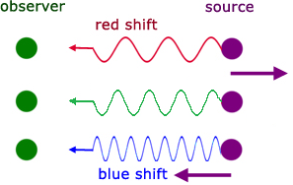
stationary object: laboratory spectrum
object moving closer: approaching galaxy

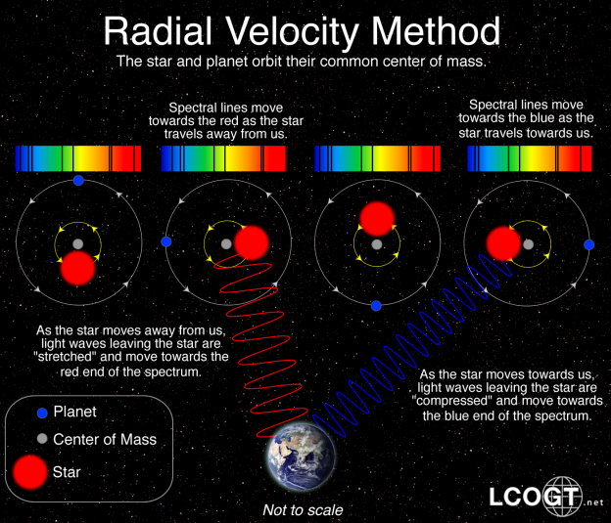
Doppler Effect

3.3o demonstrate an understanding of how stars can be classified according to their spectral type.
Astronomers have devised a classification scheme which describes the absorption lines of a spectrum. There are seven categories: OBAFGKM

The ‘spectral type’ tells you about the surface temperature of the star.
Spectral class | Temperature range/K | Colour
O | >30 000 | Blue | VERY hot
B | 10 – 30 000 | Blue-white
A | 7 500 – 10 000 | White | HOT
F | 6 – 7 500 | Yellow-white
G | 5 – 6 000 | Yellow | MEDIUM
K | 3 500 – 5 000 | Orange-yellow
M | <3 500 | Reddish-orange | COOL

3.3p demonstrate an understanding that a stars colour is related to its temperature
Colour
Example | Spica  (Virgo) | Vega  (Lyra) | Sun | Arcturus  (Bootes) | Antares  (Scorpius)
Temperature / ºC | 28 000- 11 000 | 11 000- 7 500 | 6 000- 5 000 | 5 000- 3 600 | 3 600- 2 000

3.3q sketch and recognise the main components of the Hertzsprung-Russell diagram (HR diagram).
This is a graph that plots a star’s colour/ spectral type/ temperature on the X axis and its luminosity/ brightness/ absolute magnitude on the Y axis. You need to be able to indicate where on the graph stars will be hot or cool, bright or dim, large or small.
Most stars, including the Sun, are found in a diagonal band and are called main sequence stars. Their temperatures and luminosity vary.
As stars begin to die, they cool and become giants and supergiants, which are found above the main sequence.
Hotter dimmer stars, white dwarfs, are found below the main sequence in the bottom left.

A star like our own will swell to become a giant and then dim to become a white dwarf.
